**Daily Scrum or Standup Meeting**

Team name: Group 2

Scrum Master: Max Edwards

Date:____________February 9___________________

| **Team Member** | **What did you do since the last scrum?** | **What do you plan to do before the next scrum?** | **What obstacles do you have?** |
| --- | --- | --- | --- |
| Satchell Fausett | Reviewed the Django models and documents are up to date | Make models | Time |
| Jared Hansen | Completed tutorial | Look at the database models | Getting the proper data format |
| Chase Miller | Pushed up the changes | Make models in Django | Time |
| Max Edwards | Did not do anything | Look at the database form and setup user account view | Learning enough React to work correctly |
|  |  |  |  |

# Burndown

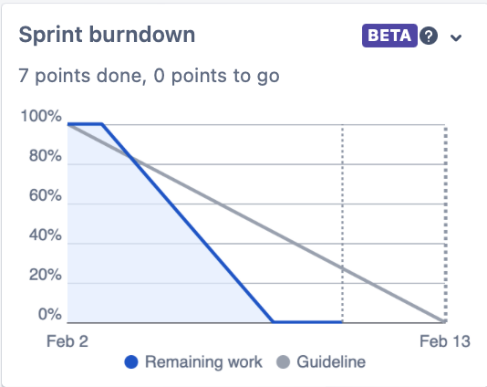

# 

# Screenshot of your project board

